*LAB # 12*

*lab task*

Take any integer as input. If the number is greater than 5, print the number. If the number is less than 5, close program. If the number is equal to zero, print statement that Number is Zero**CODE:**

**EXECUTION:**

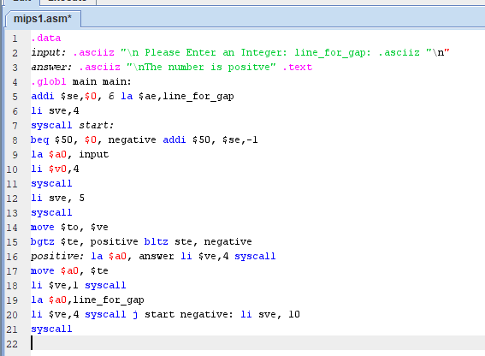

**OUTPUT:**

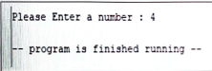

2. Take two integers as input and subtract them. If the result is positive, save and display it at the memory location of your Name

**EXECUTION:**

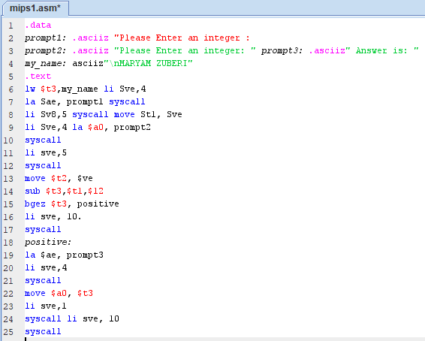

**OUTPUT:**

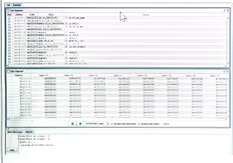

3. Write a program in MIPS assembly language that take input from user and print whether input is greater or less than 10 and also shift input left and right 4 bits

**EXECUTION:**

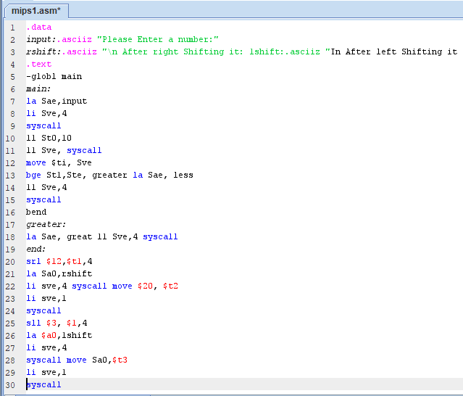

OUTPUT

